How to ask for permissions
This section explains how the permission request process works, what information you will need to provide, and what happens after you submit a request.
Note: it is important that you agree the role you need with your team before starting the request.
- You are new to NDSP and currently have no permissions.
If you sign into NDSP and do not yet have any permissions, you will land on a simplified home page.
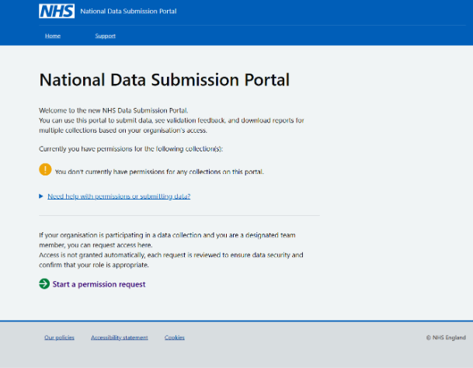
Select ‘Start a permission request’ to begin.
What you need to provide
The first screen explains what you will be asked to provide:
- The organisation (and its ODS code) you will be submitting data for
- The role you are requesting
- If required, details for your organisation’s Information Governance (IG) Lead
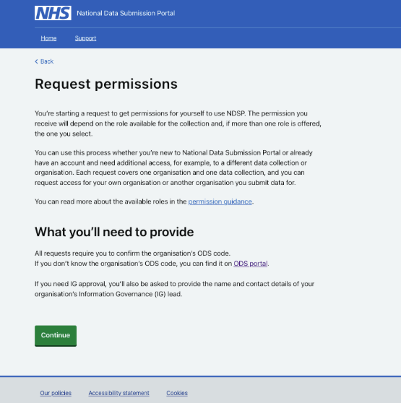
This page includes a link to the ODS portal, where you can check your organisation’s ODS code and confirm the details of its registered IG Lead.
Click ‘Continue’ to proceed.
Choose a collection
Next, you select the data collection you need permissions for.
The screen shows only collections available through NDSP at the time.
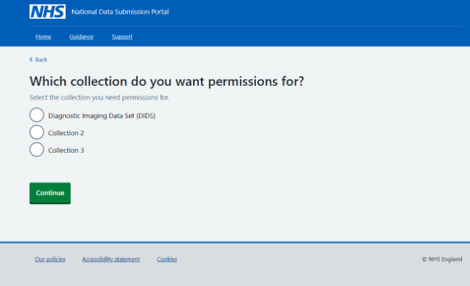
Once you have selected the collection, click ‘Continue’.
Select an organisation
You must now choose the organisation you want permissions for:
- Start typing your organisation’s name into the search box. Results will appear once you enter at least three characters.
- Select your organisation from the list. The list only includes organisations authorised to submit data for the collection you selected.
- Check that the correct ODS code appears automatically beneath the organisation name. Make sure it matches the organisation you intend to request access for.
- Once you are confident that the organisation and ODS code are correct, select ‘Continue’ to move to next step.
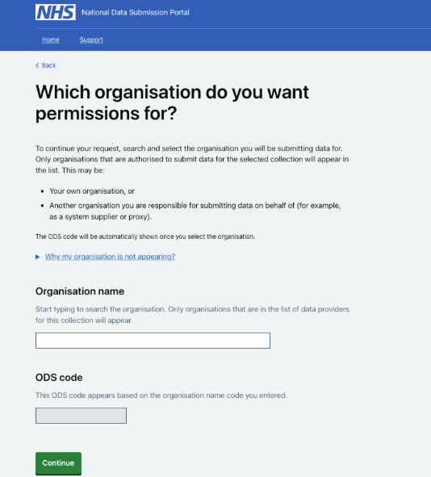
If the organisation you expect is not listed, you may need to talk to your line manager or contact the national service desk.
Select a role
You now choose the role you are applying for:
At this stage:
- Review the list of available roles shown as radio buttons. The roles displayed depend on the organisation and collection you selected.
- Select the role you need by choosing the appropriate radio button.
If only one role is available, you will still need to select it.
- Select ‘Continue’ to move to next step.
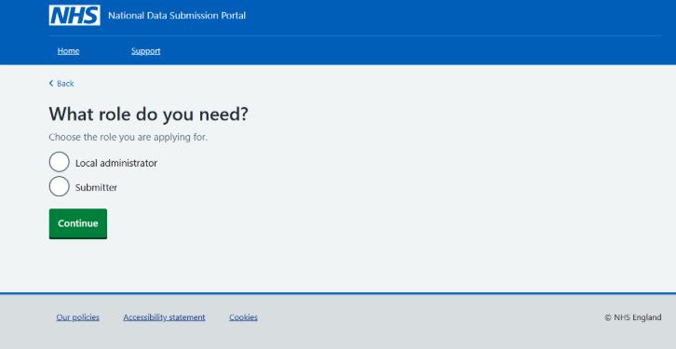
- Approval route 1: Local administrator approves the request
This route applies when:
- you request a Submitter role and
- the organisation already has a Local Administrator for that collection.
Agree to Terms and Conditions
- Select “Read terms and conditions.” This will open the full terms in a new page.
- Read the terms carefully
- Return to the request page and select “Continue.”
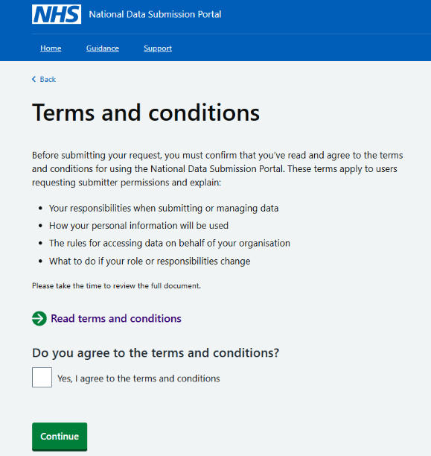
Review request details
On the summary page, check that all the information shown is correct.
If something looks wrong, you can select ‘Change’ to go back to that step and update your selection.
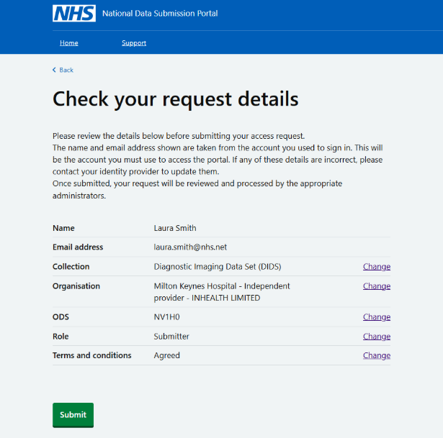
Your name and email address come from your login details and cannot be updated in the portal. If these are incorrect, you will need to contact your identity provider.
Submit the Request
After submission:
- You receive a confirmation email.
- The Local Administrator receives an email asking them to review your request.
- They log into NDSP to approve or reject it.
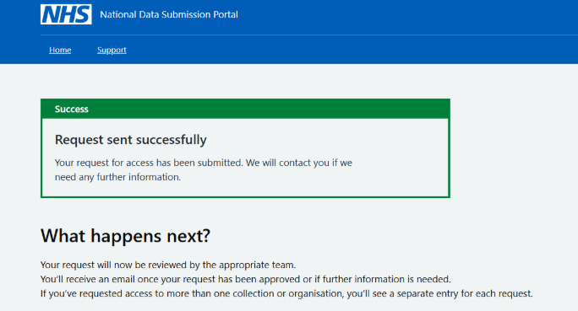
- Approval Route 2: IG Lead Approval required
If no Local Administrator exists, or if you are requesting a Local Administrator role, the request must first go to the organisation’s Information Governance (IG) Lead for approval.
This route includes some additional steps.
Provide IG Lead Contact Details
You must enter:
- IG Lead’s full name
- IG Lead’s official email address
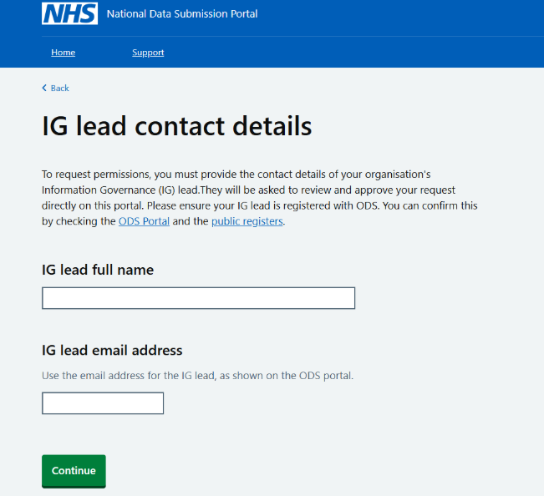
Links are provided to check IG Leads through the ODS portal and public registers.
Provide Additional Context
You must enter:
- Your team or department
- Job title
You may add:
- Reason for requesting permissions
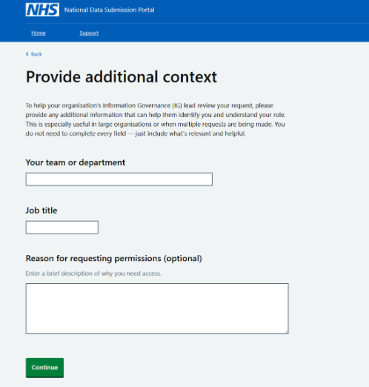
This helps IG leads, especially in large organisations, identify and approve requests more easily.

- What happens next
Once submitted:
- You receive a confirmation email.
- An email is sent to the IG Lead asking them to approve or reject the request.
- A provisioner (Service Desk team member) checks the IG Lead is authorised and then grants or rejects the request.

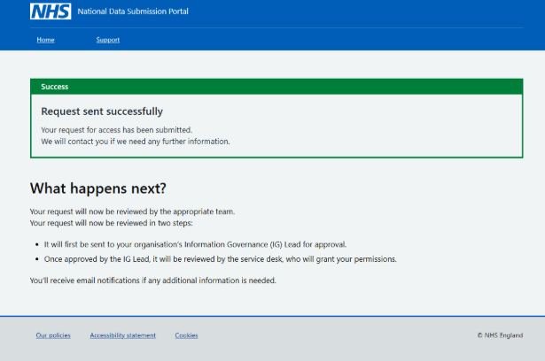
After approval, you will receive an email confirming that your access has been granted.
The next time you sign in, your home page will show your collections, deadlines, and available actions based on the role you now hold.
If the IG Lead rejects the request, you will be informed by email with a short explanation.
Once approved, you can sign in to NDSP using the same link and login method you used when submitting your permission request.
- Requesting additional permissions
Permissions are always tied to a specific organisation (ODS code) and specific data collection, and they reflect the role you have in your team.
You have to request additional permissions if you are already using NDSP but need permissions for a new collection, a new organisation, or a different role.

